* **A fall is an incident whereby a person involuntarily rests on the ground.**
* **Falls are not the outcome of a major intrinsic event or overwhelming hazard.**
* **Falling isn’t a part of aging however, as people age they are more likely to fall due age-related reduction in muscle mass, vision loss or long-term health conditions.**

Main goals of physiotherapy when working with falls patients

What is a fall?

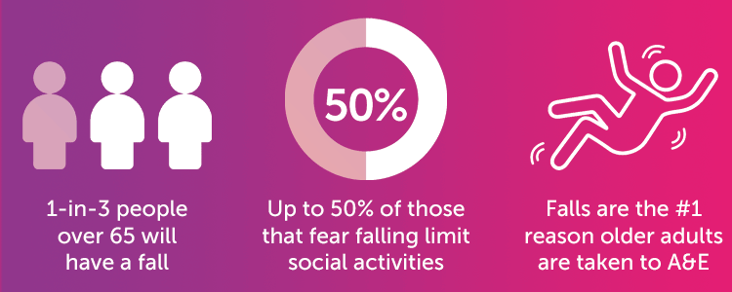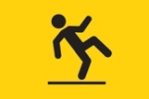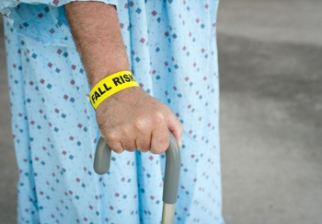

**Increased**

**Risk of Falling**

Long Lie

* **After a fall, when a patient has been lying on the ground for a prolonged period we call this a long lie.**

* **This prolonged period of being on the ground can cause problems such as pressure sores, burns, dehydration, hypothermia, pneumonia or death. Therefore, it is important that people receive the correct education around falls prevention.**

Statistics

Falls Factors

(from the UK Department of Work and Pensions site)

What is a fall?

Falls prevention strategies

<https://www.ageuk.org.uk/information-advice/health-wellbeing/exercise/falls-prevention/> - age UK works with older adults; the charity provides information and support to individuals who are at higher risk of falling.

<https://www.ageuk.org.uk/hillingdonharrowandbrent/our-services/falls-service/> - This link provides information around falls prevention and has contact details to speak to the falls team for any further information.

<https://www.physio-pedia.com/Otago_Exercise_Programme> - Otago is an exercise programme that was developed to reduce falls in the older population. This link provides more information.

<https://lp.helpline.co.uk/fall-alarms-for-the-elderly/?infinity=ict2~net~gaw~cmp~11311255143~ag~120935349569~ar~500589736249~kw~fall%20alarm~mt~b~acr~5200521142&gad=1&gclid=EAIaIQobChMI0_j-qJ-ggQMVWtbtCh0x_QCxEAMYASAAEgJ_p_D_BwE> – Helpline is a personal lifeline alarm that an individual can use if they become unwell or have a fall. They will send out the appropriate team to help resolve the persons problem. See link for more information.

Useful Resources

Evidence

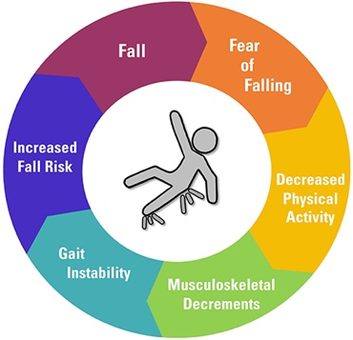

References:

Office for Health Improvement & Disparities. (2021) Falls applying All Our Health: Available: <https://www.gov.uk/government/publications/falls-applying-all-our-health/falls-applying-all-our-health#:~:text=A%20fall%20is%20defined%20as,normal%20result%20of%20human%20anatomy>. [Accessed: 5/9/2023]

<https://www.physio-pedia.com/Falls>

<https://apcp.csp.org.uk/system/files/agile_falls_guidelines_update_2012_1.pdf>

<https://www.nhs.uk/conditions/falls/>

<https://www.bellavistahealth.com/blog/gait-training-exercises-for-elderly>

The Chartered Society of Physiotherapy (2012)

